Free Youtube views for an unlimited number of your videos! Boost your video's popularity using their simple and free method! Or, buy Youtube views and other services here.

[ythunder.com](https://ythunder.com/) has free & open registrations.

Why have a [YouTube](https://ythunder.com/) Channel?

[YouTube](https://ythunder.com/) is a brilliant tool to help you maximize your online presence. Its potentials are astounding and often not used to the full by individuals and entrepreneurs.

Free Youtube views：[ythunder.com](https://ythunder.com/)

If you want to stand apart from the crowd and would like to have a personal or professional presence on the World Wide Web, it is time to jump on the [YouTube](https://ythunder.com/) bandwagon![YouTube](https://ythunder.com/) is excellent for representing businesses as it is an effective tool for engaging users, providing the latest information as well as gathering feedback.

A great way to enter into the [YouTube](https://ythunder.com/) arena is to have a professional, impressivepublic [YouTube](https://ythunder.com/)channel that can be easily found, viewed and subscribed to by everyone. Basically, all [YouTube](https://ythunder.com/) Channels are public by default now, however, the videos need to be public too in order to be seen.

If however, your [YouTube](https://ythunder.com/) channel was made prior to Google’s change inthe privacy policy, you had the option of making the channel hidden at that time, and if you had done that,  you would now need to set the channel to public in order for it to be seen by everyone.

Free Youtube views：[ythunder.com](https://ythunder.com/)

Another thing to remember is that a [YouTube](https://ythunder.com/) channel will appear in search results only if it has at least three videos uploaded. Therefore,three videos are the least that you should consider uploading.

Here’s how to set your [YouTube](https://ythunder.com/) channel public in 6 basic steps.

The 6 steps to making your [YouTube](https://ythunder.com/) Channel Public

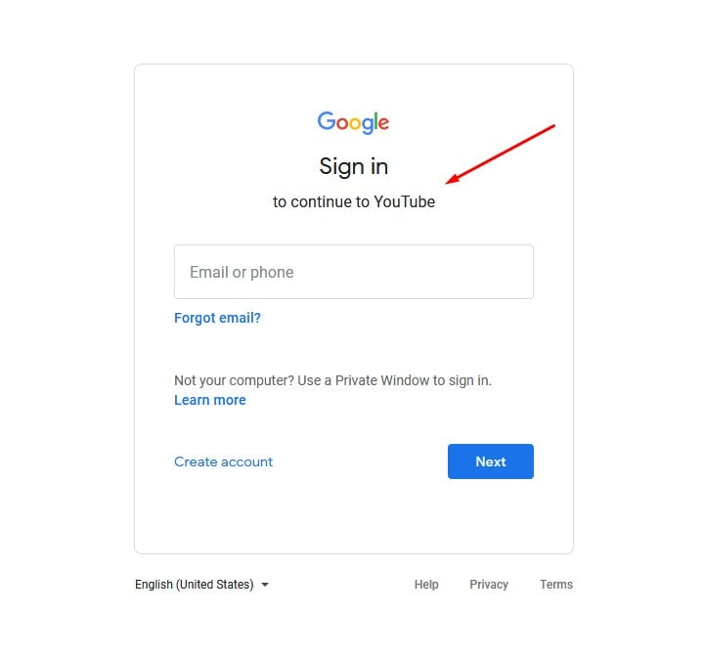

Step 1: Sign in to [YouTube](https://ythunder.com/)

Be it a laptop, desktop or mobile device, open up [YouTube](https://ythunder.com/) either through your browser or clicking the App icon. Sign in to your [YouTube](https://ythunder.com/) Account if you have not already.

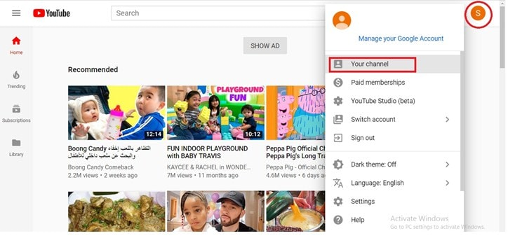

Step 2: Open Channel

Click on the colored icon on the top right. Click ‘Your Channel’ when the list opens.

DCE97EE72D384FDC9666023EFE600AC3.jpeg

**lifesang**

Step 3: Customize Channel

Click the customize channel blue button.

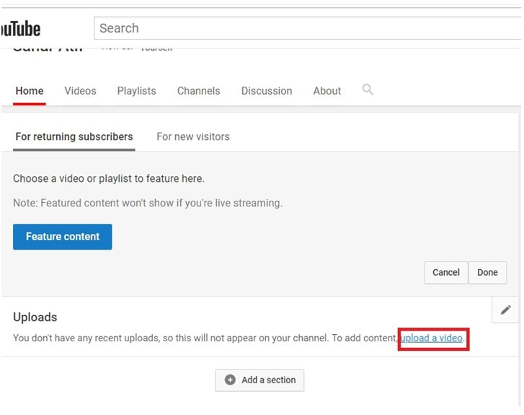

Step 4: Upload Videos

If you have not uploaded any videos, it is time to do that now by clicking the ‘Upload a Video’ tag from the Uploads section.

Videos can be uploaded either by browsing through files on PC by clicking the Upload Arrow button.

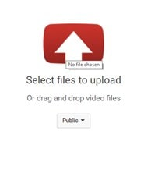

Or simply by dragging and dropping the required video file on this space.

Step 5: Select the Video Privacy Setting

Select ‘Public’ from the four available options for setting either before or after the video uploads. This will affect each video separately and needs to be set to Public if you would like your previously uploaded videos files to be available for the public.

Note: In case you do not desire for a video to be made public or not just yet, you can use Unlisted, Private or Scheduled setting.

You can upload multiple videos at a time

While the video is uploading, you can add descriptions, Set privacy or edit ‘advance settings’.

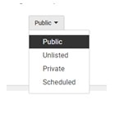

Step 6: Publish the Video

Click Publish to publish the video on your channel. Remember, if you do not click publish, your video will not be viewable to others or won’t display on your channel. Therefore, it is important to click publish unless you do not desire for a video to be made public.

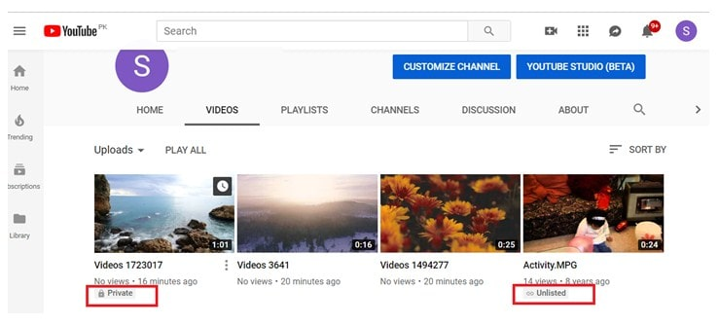

Pro tip:

When you go to the videos section of your account, you can see the list of videos uploaded. Any video that has the sign ’Private’ or ‘Unlisted’ will be marked as that. You can easily change the setting right from there to set the video as Public. Simply click on Private icon, then click edit video, click the ‘Visibility’ tab and select Public. Click Done. Then click Save from the top right corner of the page in order to save the changes.

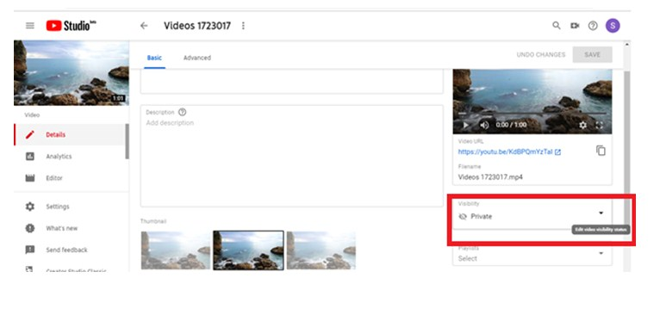

This is how to make a [YouTube](https://ythunder.com/) channel public.

You can make sure that your [YouTube](https://ythunder.com/) channel is visible to others, by handling the privacy setting on a video by video basis.

Making Old [YouTube](https://ythunder.com/) Account Channels Public

If your account was made before [YouTube](https://ythunder.com/) Privacy settings changed, it is possible that your [YouTube](https://ythunder.com/) channel was hidden. Here is how you can set a hidden or unlisted [YouTube](https://ythunder.com/) channel to public.

Click your profile icon from the top right of the page and then go to ‘Settings’. Then click the ‘Advanced Settings’ tab from the left bar. Select ‘Make this channel public’.

What’s Next?

Once you are all set to having a public channel, it is extremely important to provide original, quality content on your [YouTube](https://ythunder.com/) channel which would keep users interested in your channel and would increase the number of subscribers. Your subscribers would be instantly notified of any video you upload, therefore the number of subscribers is a key metric for a [YouTuber](https://ythunder.com/)’s success.

A successful [YouTube](https://ythunder.com/) channel needs your constant attention and effort. Happy YouTubing!Free Youtube views for an unlimited number of your videos! Boost your video's popularity using their simple and free method! Or, buy Youtube views and other services here.

[ythunder.com](https://ythunder.com/) has free & open registrations.